1.

*#!/usr/bin/python*a, b = 20, 10  
c = a + b  
**print '\n Addition of two numbers is'**, c  
c = a-b  
**print '\n Subtraction of two numbers is'**, c  
c = a * b  
**print '\n Multiplication of two numbers is'**, c  
c = a / b  
**print '\n Division of two numbers is'**, c

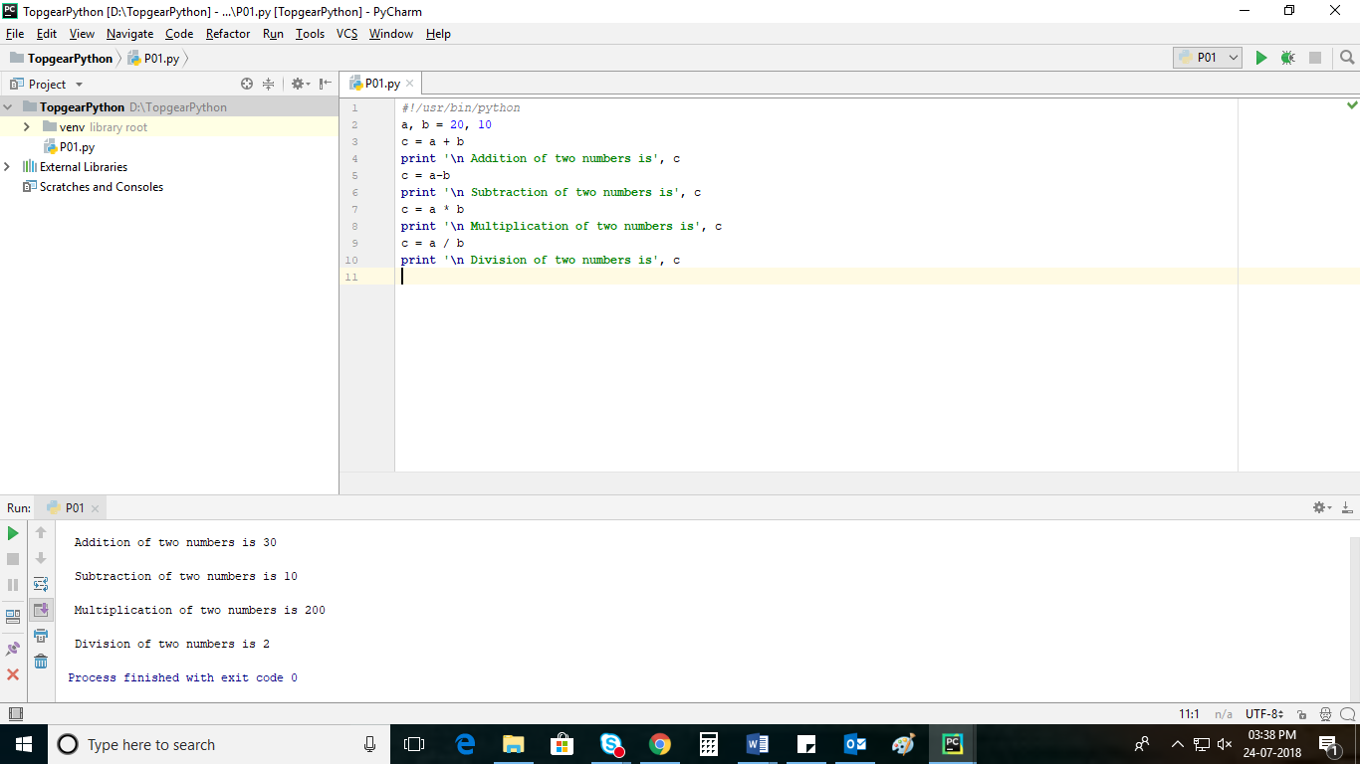

2.

*#!/usr/bin/python*a, b, c = 20, 10, 30  
**if** a > b **and** a > c :  
 **print 'Biggest of three numbers is'**, a  
**if** b > a **and** b> c :  
 **print 'Biggest of three numbers is'**, b  
**if** c > a **and** c > b :  
 **print 'Biggest of three numbers is'**, c

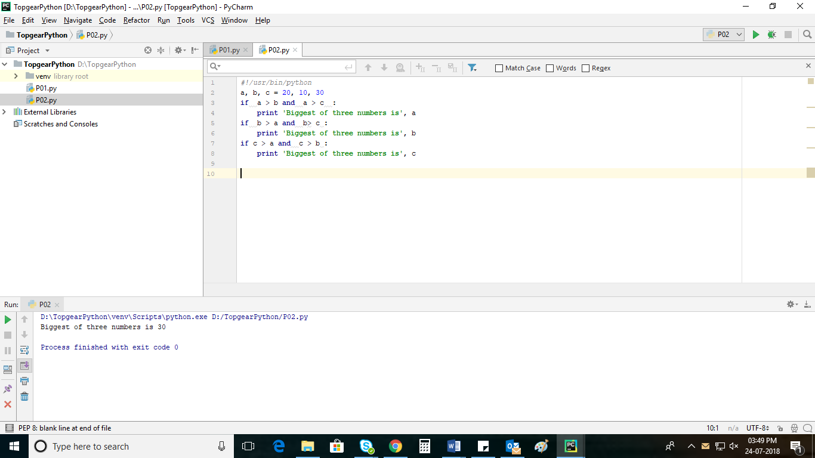

3.

*#!/usr/bin/python*a = 10  
b = a % 2  
**if** b == 0 :  
 **print 'Given number is'**, a,**'even'  
else** :  
 **print 'Given number is'**, a,**'odd'**

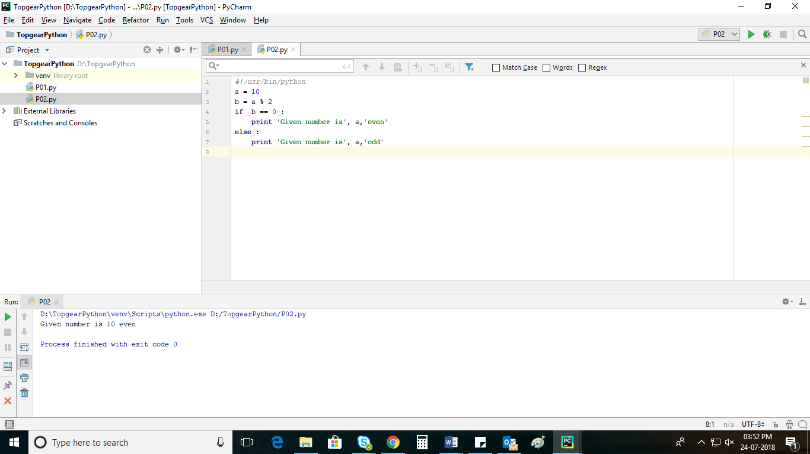

4

*#!usr/bin/python*a = 7  
**for** i **in** ( 2, a-1 ):  
 **if** a % i == 0 :  
 **print 'The given number '**, a,**'is not prime'  
 else** :  
 **print 'The given number '**,a,**'is prime'**

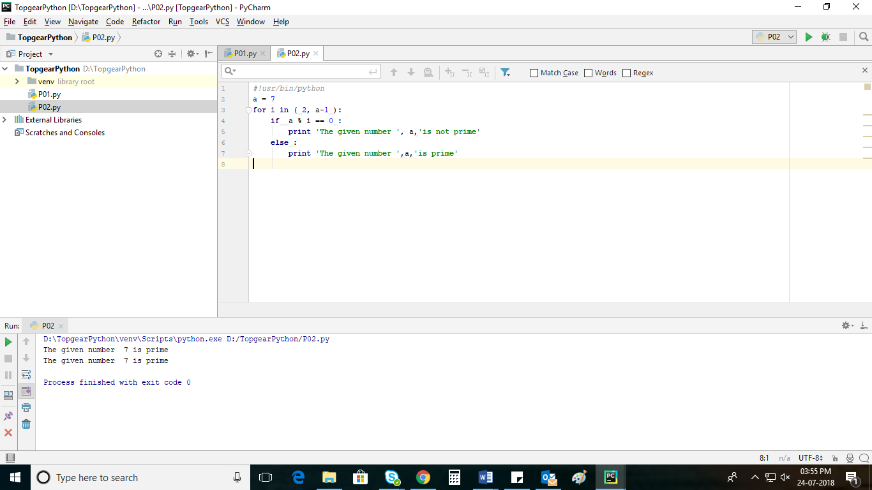

5.

**import** sys  
arg1,arg2,arg3,arg4,arg5=sys.argv[0],sys.argv[1],sys.argv[2],sys.argv[3],sys.argv[4]  
**print "arg1="**,arg1  
**print "arg2="**,arg2  
**print "arg3="**,arg3  
**print "arg4="**,arg4  
**print "arg5="**,arg5  
  
arg3,arg4,arg5=input(**"Enter 3 numbers"**)  
**if** arg3>arg4 **and** arg3>arg5:  
 **print "the biggest no is"**,arg3  
**elif** arg4>arg3 **and** arg4>arg5:  
 **print "the biggest no is"**,arg4  
**else**:  
 **print"the biggest no is"**,arg5

6.

7.

*#!/usr/bin/python*List = [ 12, 23,**'Hello'**, 60.6,**'Chennai'**]  
List1 = [ 21, 32, 60 ]  
a = List [ 1:3 ]  
b = List * 2  
c = List + List1  
**print** List  
**print '\n'**,a  
**print '\n'**,b  
**print '\n'**,c

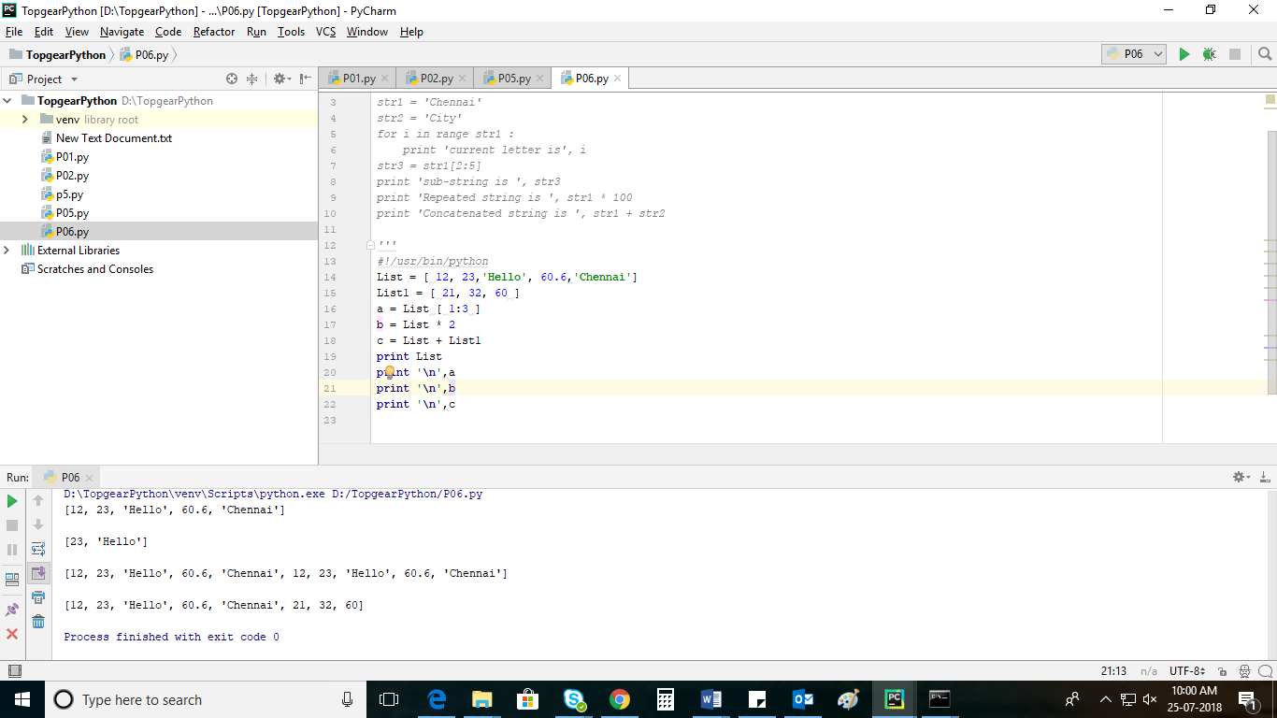

8.

*#!/usr/bin/python*Tuple = ( 12, 23,**'Hello'**,60.6,**'Chennai'** )  
Tuple1 = ( 21, 32, 60 )  
a = Tuple[ 1:3 ]  
b = Tuple * 2  
c = Tuple + Tuple1  
**print** Tuple  
**print '\n'**, a  
**print '\n'**, b  
**print '\n'**, c

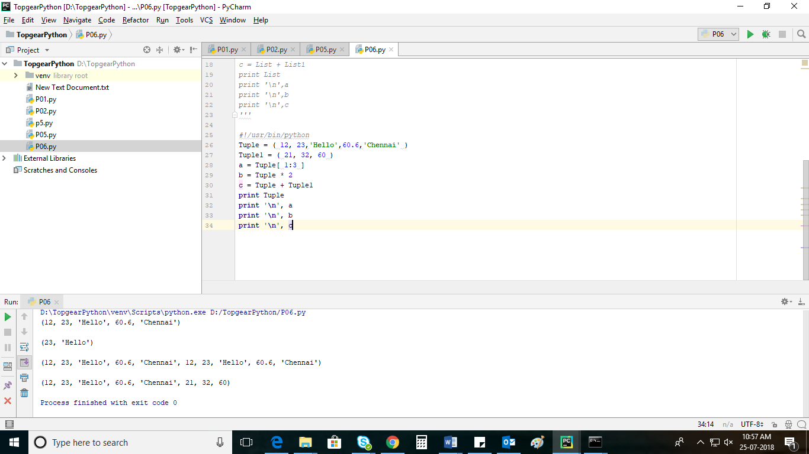

9.

*#!/usr/bin/python*a = complex(arg[0], arg[1])  
b = complex (arg[2], arg[3])  
c = a + b  
**print '\n Addition of two numbers is'**, c  
c = a-b  
**print '\n Subtraction of two numbers is'**, c  
c = a * b  
**print '\n Multiplication of two numbers is'**, c  
c = a / b  
**print '\n Division of two numbers is'**, c

10.

arg[0] += arg[1]  
**print '\n Addition of two numbers is'**, arg[0]  
arg[0] -= arg[1]  
**print '\n Subtraction of two numbers is'**, c  
arg[0] *= arg[1]  
**print '\n Multiplication of two numbers is'**, c  
arg[0] /= arg[1]  
**print '\n Division of two numbers is'**, c  
arg[0] %= arg[1]  
**print '\n modulus of two numbers is'**, c  
arg[0] **= arg[1]  
**print '\n Exponentiation of two numbers is'**, c  
arg[0] //= arg[1]  
**print '\n Floor division of two numbers is'**, c

11.

*# !/usr/bin/python*a = arg[0] **and** arg[1]  
b = arg[0] **or** arg[1]  
c = **not** (arg[0] **and** arg[1])  
**print** a  
**print** b  
**print** c